We have discussed-

* Binary tree is a special tree data structure.
* In a binary tree, each node can have at most 2 children.

In this article, we will discuss about Binary Tree Traversal.

**Tree Traversal-**

|  |
| --- |
| Tree Traversal refers to the process of visiting each node in a tree data structure exactly once. |

Various tree traversal techniques are-

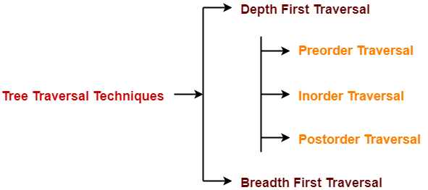

**Depth First Traversal-**

Following three traversal techniques fall under Depth First Traversal-

1. Preorder Traversal
2. Inorder Traversal
3. Postorder Traversal

**1. Preorder Traversal-**

**Algorithm-**

1. Visit the root
2. Traverse the left sub tree i.e. call Preorder (left sub tree)
3. Traverse the right sub tree i.e. call Preorder (right sub tree)

**Root**→**Left**→**Right**

**Example-**

Consider the following example-

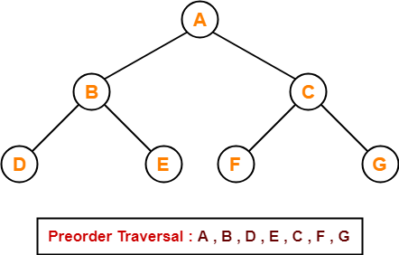

|  |
| --- |
| **Preorder Traversal Shortcut**    Traverse the entire tree starting from the root node keeping yourself to the left.    https://www.gatevidyalay.com/wp-content/uploads/2018/07/Preorder-Traversal-Shortcut-1.png |

**Applications-**

* Preorder traversal is used to get prefix expression of an expression tree.
* Preorder traversal is used to create a copy of the tree.

**2. Inorder Traversal-**

**Algorithm-**

1. Traverse the left sub tree i.e. call Inorder (left sub tree)
2. Visit the root
3. Traverse the right sub tree i.e. call Inorder (right sub tree)

**Left**→**Root**→**Right**

**Example-**

Consider the following example-

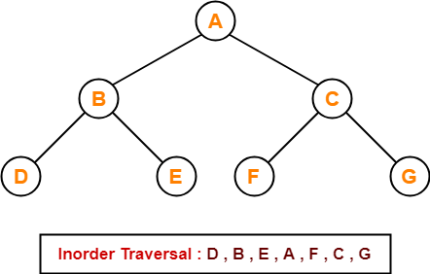

|  |
| --- |
| **Inorder Traversal Shortcut**    Keep a plane mirror horizontally at the bottom of the tree and take the projection of all the nodes.    https://www.gatevidyalay.com/wp-content/uploads/2018/07/Inorder-Traversal-Shortcut-1.png |

**Application-**

* Inorder traversal is used to get infix expression of an expression tree.

**3. Postorder Traversal-**

**Algorithm-**

1. Traverse the left sub tree i.e. call Postorder (left sub tree)
2. Traverse the right sub tree i.e. call Postorder (right sub tree)
3. Visit the root

**Left**→**Right**→**Root**

**Example-**

Consider the following example-

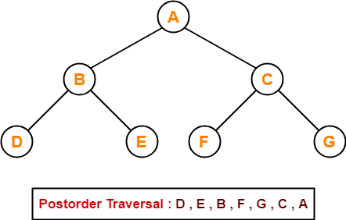

|  |
| --- |
| **Postorder Traversal Shortcut**    Pluck all the leftmost leaf nodes one by one.    https://www.gatevidyalay.com/wp-content/uploads/2018/07/Postorder-Traversal-Shortcut-1.png |

**Applications-**

* Postorder traversal is used to get postfix expression of an expression tree.
* Postorder traversal is used to delete the tree.
* This is because it deletes the children first and then it deletes the parent.

**Breadth First Traversal-**

* Breadth First Traversal of a tree prints all the nodes of a tree level by level.
* Breadth First Traversal is also called as **Level Order Traversal**.

**Example-**

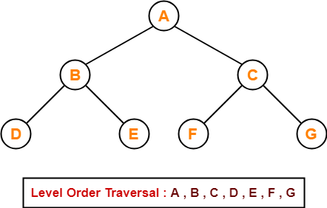

**Application-**

* Level order traversal is used to print the data in the same order as stored in the array representation of a complete binary tree.

To gain better understanding about Tree Traversal,

[**Watch this Video Lecture**](https://www.youtube.com/watch?v=YJdFAa714B0)

**Also Read-** [**Binary Tree Properties**](https://www.gatevidyalay.com/binary-tree-properties-important-formulas/)

**PRACTICE PROBLEMS BASED ON TREE TRAVERSAL-**

**Problem-01:**

If the binary tree in figure is traversed in inorder, then the order in which the nodes will be visited is ____?

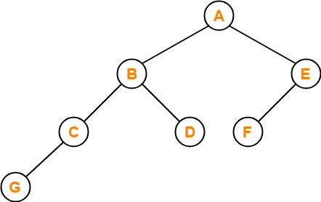

**Solution-**

The inorder traversal will be performed as-

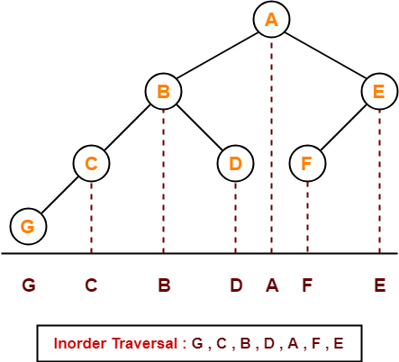

**Problem-02:**

Which of the following sequences denotes the postorder traversal sequence of the tree shown in figure?



1. FEGCBDBA
2. GCBDAFE
3. GCDBFEA
4. FDEGCBA

**Solution-**

Perform the postorder traversal by plucking all the leftmost leaf nodes one by one.

Then,

Postorder Traversal :  G , C , D , B , F , E , A

Thus, Option (C) is correct.

**Problem-03:**

Let LASTPOST, LASTIN, LASTPRE denote the last vertex visited in a postorder, inorder and preorder traversal respectively of a complete binary tree. Which of the following is always true?

1. LASTIN = LASTPOST
2. LASTIN = LASTPRE
3. LASTPRE = LASTPOST
4. None of these

**Solution-**

Consider the following complete binary tree-

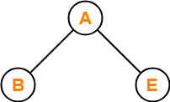

Preorder Traversal  : B , A , E

Inorder Traversal     : B , A , E

Postorder Traversal : B , E , A

Clearly, LASTIN = LASTPRE.

Thus, Option (B) is correct.

**Problem-04:**

Which of the following binary trees has its inorder and preorder traversals as BCAD and ABCD respectively-

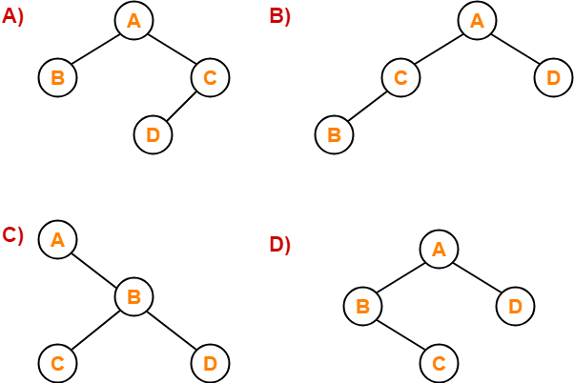

**Solution-**

Option (D) is correct.